1.What are the two values of the Boolean data type? How do you write them?

True=1 and False=0

2. What are the three different types of Boolean operators?

AND/ OR/ NOT

3. Make a list of each Boolean operator's truth tables (i.e. every possible combination of Boolean values for the operator and what it evaluate ).

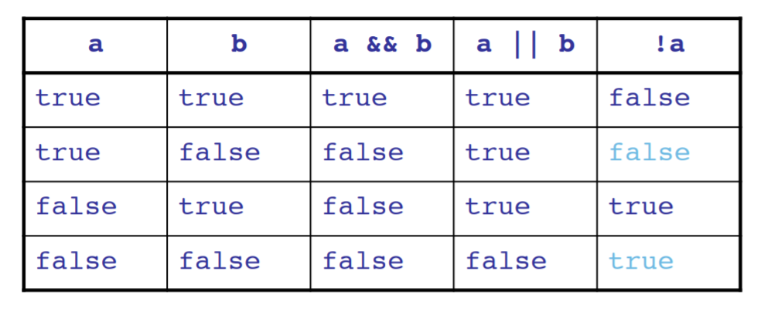

4. What are the values of the following expressions?

(5 > 4) and (3 == 5)

False

not (5 > 4)

False

(5 > 4) or (3 == 5)

True

not ((5 > 4) or (3 == 5))

False

(True and True) and (True == False)

False

(not False) or (not True)

True

5. What are the six comparison operators?

<,>,==,!=,<=,>=

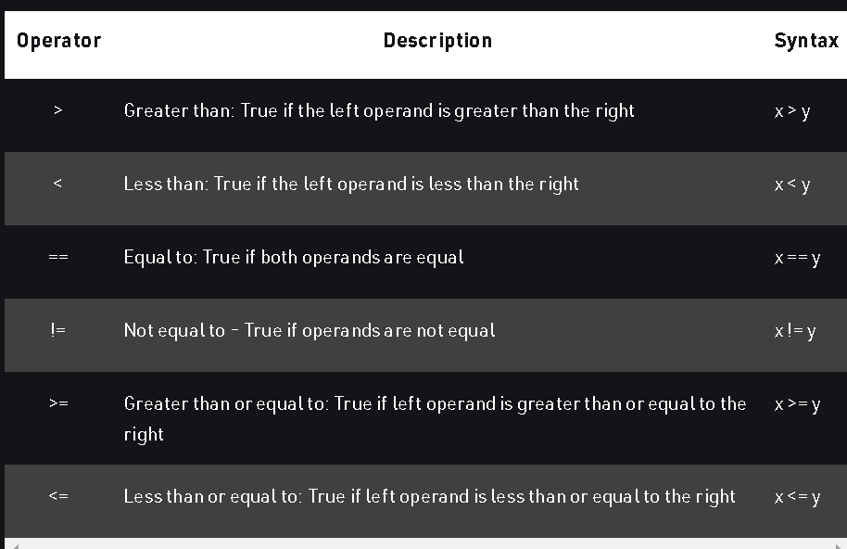

6. How do you tell the difference between the equal to and assignment operators? Describe a condition and when you would use one.

**Assignment**- is used for given value to variable. (=)

**Equal to-** The ‘==’ operator checks whether the two given operands are equal or not. If so, it returns true. Otherwise it returns false.

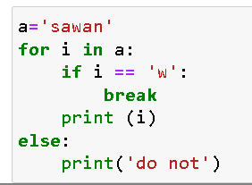

7. Identify the three blocks in this code:

spam = 0

if spam == 10:

print('eggs')

if spam > 5:

print('bacon')

else:

print('ham')

print('spam')

print('spam')

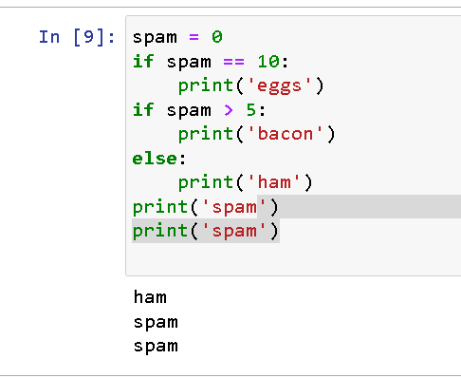

**Line 3, 5 and 7**

8. Write code that prints Hello if 1 is stored in spam, prints Howdy if 2 is stored in spam, and prints Greetings! if anything else is stored in spam.

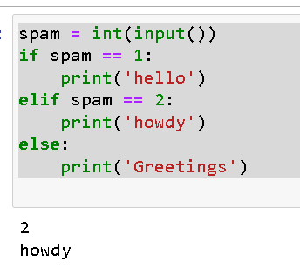

9.If your programme is stuck in an endless loop, what keys you’ll press?

**Stop Key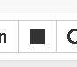 and Ctrl +C**

10. How can you tell the difference between break and continue?

**Break**- It ends the loop and move to next operation.

**Continue**- it only skip the particular condition, however it never ends the loop.

11. In a for loop, what is the difference between range(10), range(0, 10), and range(0, 10, 1)?

All are same, range (0,10) inform starting point 0 and end point 10.

Range (0,10,1) inform starting point 0, end point 10 and inform staps (+1) which is default otherwise

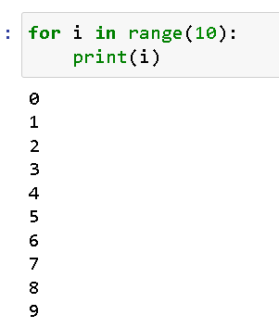 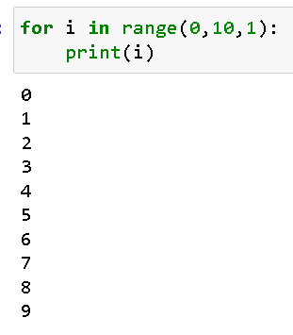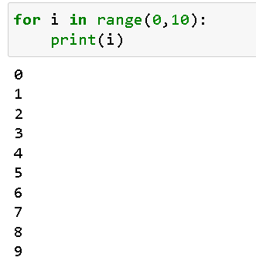

12. Write a short program that prints the numbers 1 to 10 using a for loop. Then write an equivalent program that prints the numbers 1 to 10 using a while loop.

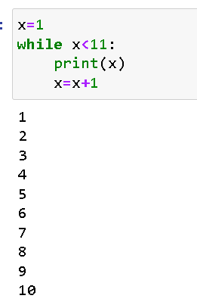 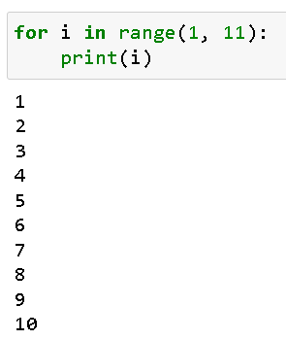

13. If you had a function named bacon() inside a module named spam, how would you call it after importing spam?

Spam.bacon()